Rdf Task outline:

1.Extract class label from ontology file :

I have extracted class labels using Rdf Lib in Python.

2.Read CSV or text file and display the data :

1. I have the impression that the tool will allow readers to read the CSV data(headers) and users(material experts) will choose Ontology class labels for a header.
2. For example, the user will see below web-page or user interface(UI):

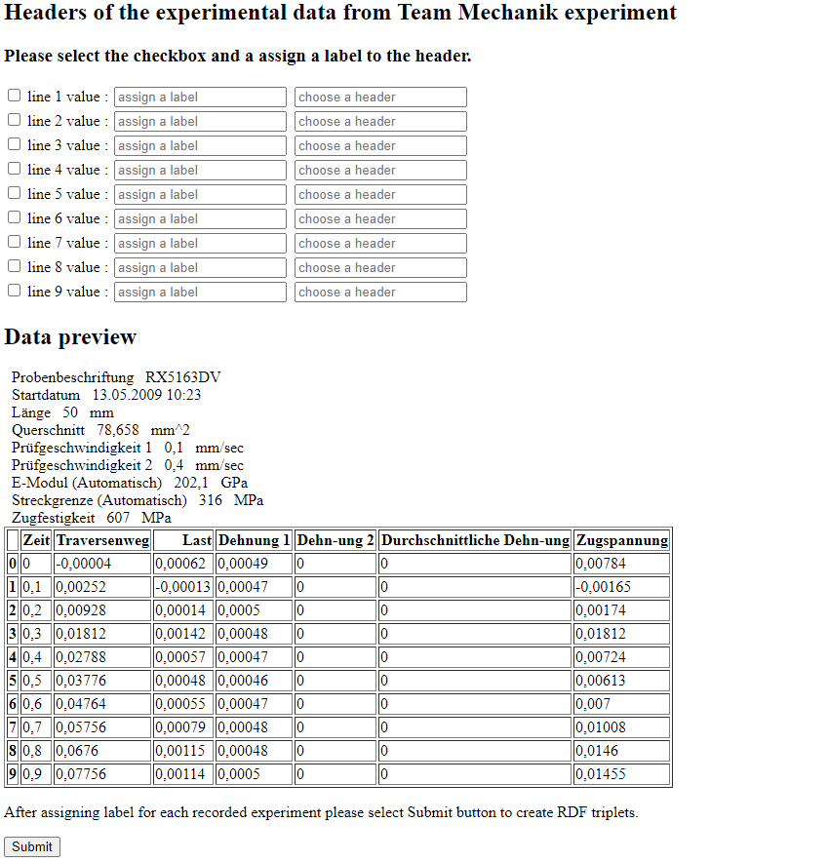

3. In the next step, a user will select a class label to the corresponding header. For example: Class label **Specimen(chosen by user)** will be assigned to **Probenbeschriftung(chosen by user)[this is simple UI but a mouse right click can also be implemented if user doesn’t want to type the header)** and it’s value **RX5163DV** will be assigned to it.



4. Triple will be formed as :

<Specimen> hasIndentifier “Probenbeschriftung”; hasValue “RX5163DV”

5. Since the value **RX5163DV** keeps on changing **(I might not be correct here, but this is what I have understood)** depending on experiments so the tool will hold the relation of Specimen and Probenbeschriftung.

Specimen definition can be found as :

**Https://Www.Materials.Fraunhofer.De/Ontologies/Bwmd_Ontology/Domain#Bwmd_00607**

6. Since in 4th step RDF generated was not meaningful so I will follow below approach:

<Https://Www.Materials.Fraunhofer.De/Ontologies/Bwmd_Ontology/Domain#Bwmd_00607> rdf:type owl:Class ;

Rdfs:type own:ObjectProperty;

Rdfs:comment: “This is specimen”

rdfs:Label “Specimen”

Then I will extend the rdf.